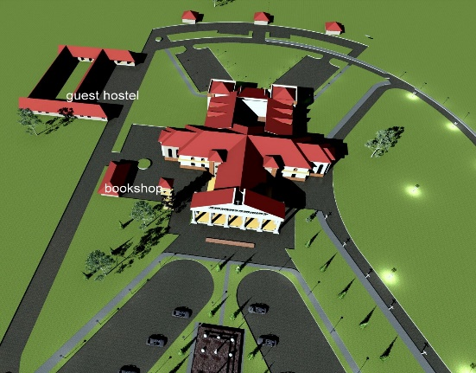
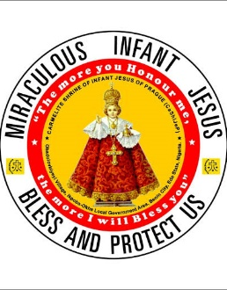
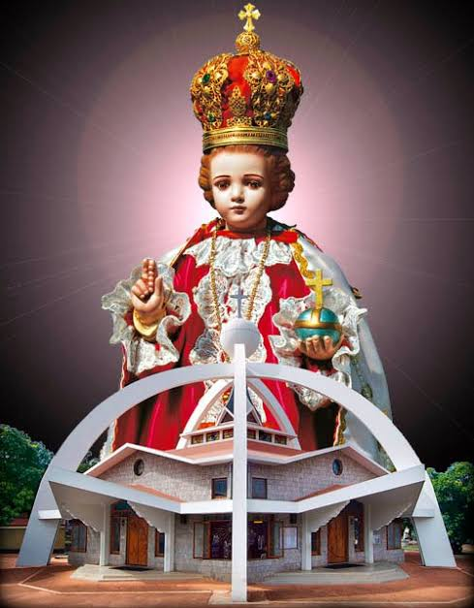
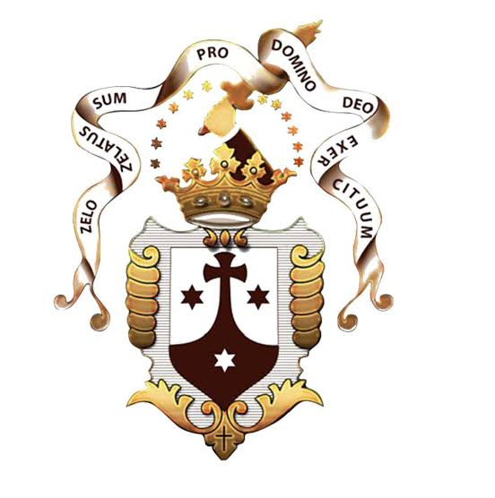
Master plan of the Infant Jesus Shrine
Together, let us raise this Shrine to the glory of God and the salvation of souls.
DONOR PLEDGE CARD
Name: ____________________ _________________________
Phone/Email: ______________ __________________________
One - time Donation:
N ____________________
Monthly Support:
N ____________ (for ___ months)
Quarterly / Annual Support
N ______________
Others (in - kind / material)
___________________________
ACCESS BANK PLC
DISCALCED CARMELITE BENIN
0689513017
KEYSTONE BANK
MONASTERY OF INFANT JESUS
1006151198
CARMELITE SHRINE OF INFANT JESUS OF PRAGUE
SPIRITUAL ACTIITIES
Sunday Mass: 9 am
Monthly Novena: 16th - 24th (25th Thanksgiving Mass)
Retreat & Counselling
Pilgrimages (Annual & Monthly)
Weekly Masses for Benefactors & Donors (Wednesdays)
Intercessory Prayers: Book a Mass / Submit Prayer Petitions / Light a votive candle.
For more enquiries/ bookings/ prayers/thanksgiving/ support:
CONTACT THE RECTOR: FR. JUDE .A. BASIKORO, OCD
+234 - 9032882824
VISIT THE SHRINE: Obadolovbiyeyi Village, Ikpoba-Okha LGA, Edo State, Nigeria.

BUILDING A BEFFITING SHRINE
The Infant Jesus awaits your “yes.”

